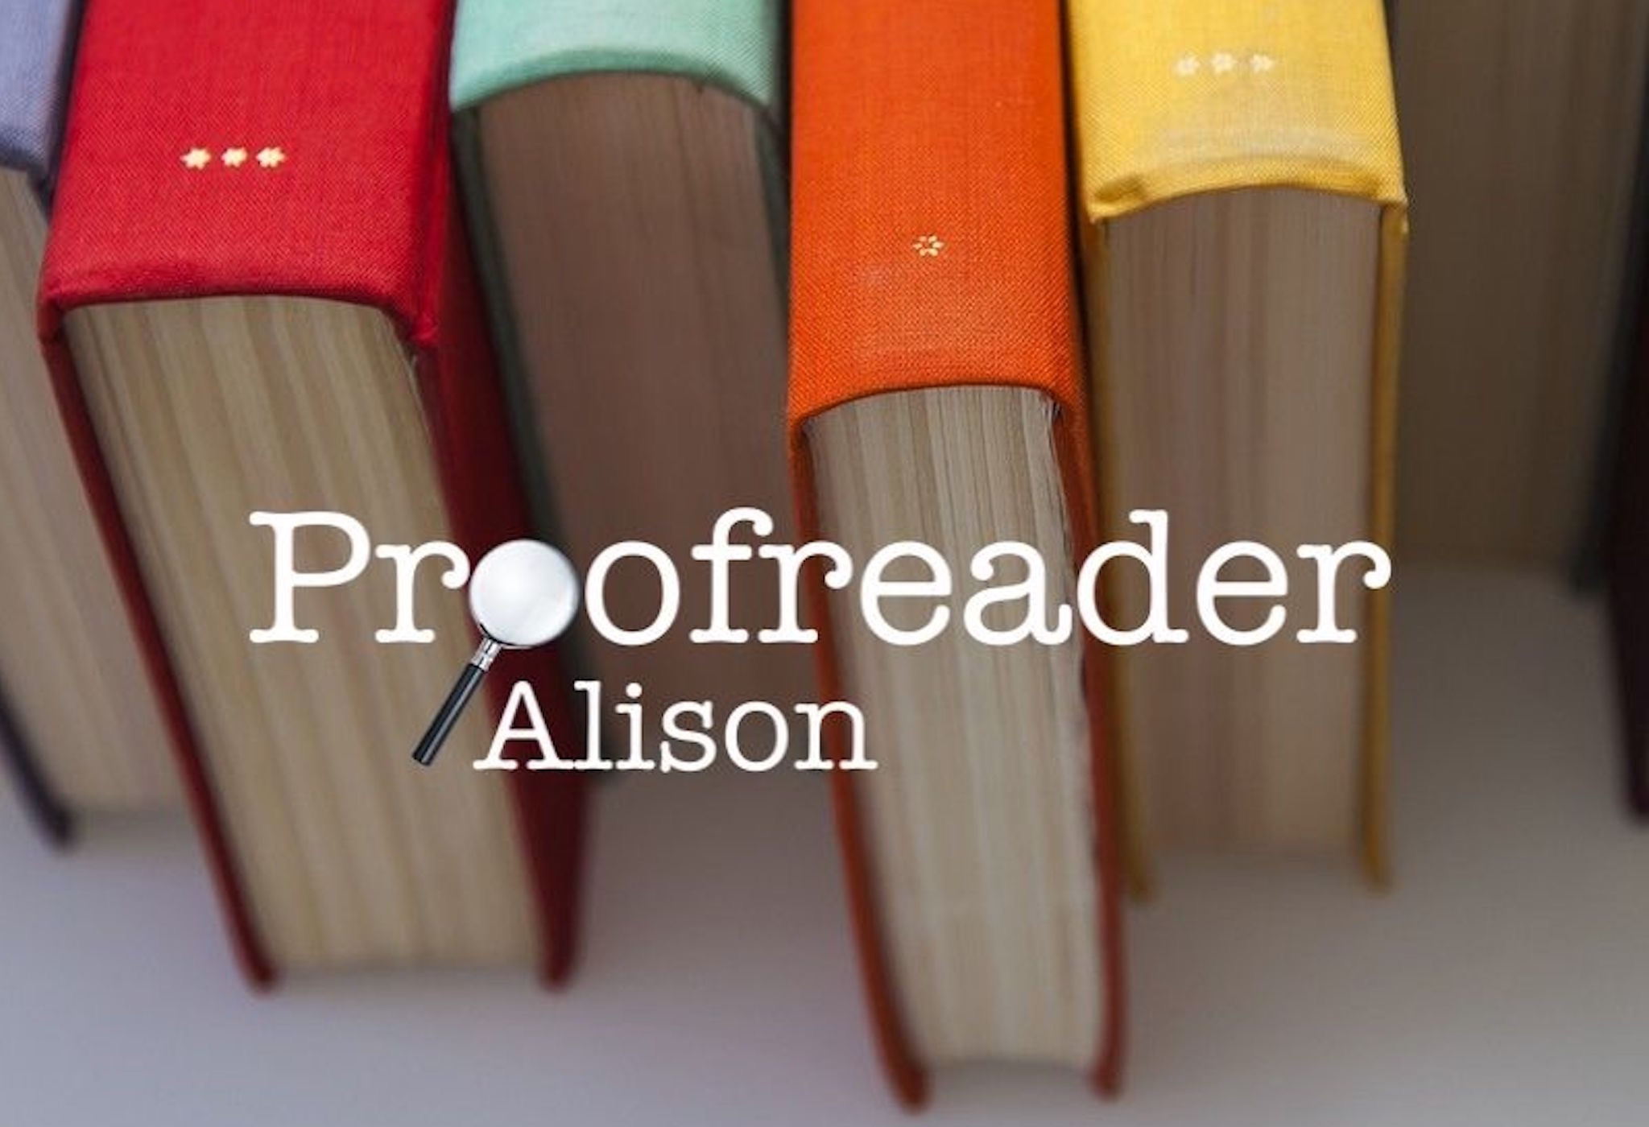
Alison Gilbert
Mobile 07941027527 • E-mail contact@alisonproofreader.com • Website www.alisonproofreader.com

PROFILE I am a freelance proofreader who specialises in educational and mathematical documents. I have a passion for education and a love of learning! I am constantly striving to improve my own skills and knowledge. I studied mathematics to degree level and have a very analytical mind. I am great with figures, maps, diagrams and finer details. I have experience checking maths from primary to degree level. I am thorough and organised, enjoying working through a project, checking every detail to ensure it is ready for publication.
I have worked in education for 17 years. I have continued my professional development learning new skills and undertaken a variety of roles from Primary School Teacher, Early Years Manager, Foundation Stage Curriculum Co-ordinator and Teaching Assistant. My background in education has supported me to proofread teachers’ phonics guides, maths textbooks and online learning modules.
EDUCATION Chartered Institute of Editing and Proofreading Training
Courses - Introduction to Proofreading, Proofreading Headway, Proofreading Progress - 2019
The courses enabled me to build a good foundation of proofreading and develop skills in using BSI proofreading symbols and commenting tools in Microsoft Word and Adobe Acrobat.

Early Years Professional Status
Manchester Metropolitan University – 2007 to 2008
The course enabled me to learn about children’s learning progression from birth to 7 years old. It gave me practice at documenting and cross-referencing different elements of my own practice.

BSc Maths with Qualified Teacher Status – Upper Second Class Honours
Lancaster University (St Martin’s College) – 1997 to 2001
During the course, I developed an in-depth understanding of Primary Education and Mathematics to a high level. The course enabled me to learn about pedagogy theories, course planning and teaching theories.

SKILLS Proofreading, Copyediting and Maths checking.
Microsoft Word using Track changes and commenting tools.
Adobe Acrobat using commenting tools and BSI proofreading symbols.
Sound knowledge of BSI proofreading symbols.
Cross-referencing across different elements of a project, including the teachers’ book, pupils' book and PowerPoint presentation.
Working with a variety of applications as part of a team.
Following a house style.
I have specialised in primary education with a focus on early years and phonics. I have proofread educational textbooks, e-learning resources and non-fiction texts. For example, ‘Maths Mastery Reasoning’ and ‘Grammarsaurus’ for Bloomsbury Education. I can work digitally as part of a team recording my comments using Smartsheet, Microsoft Office suite, Google Drive, SharePoint, Okta and Trello. I have worked for publishers following a house style and can create my own style sheet when working on a project.
EXPERIENCE Freelance Proofreader – Alison Proofreader
Feb 2019 – Present
I have experience in proofreading over 5,000 hours of educational and mathematical content. Proofreading Teachers’ Phonics Guides for Letterland, Teachers’ Maths textbooks for Bloomsbury Education and Oxford University Press, a Teacher resource book on developing outstanding writing for Brilliant Publications and a non-fiction book for Watkins Publishing. Proofreading educational assessments and online university learning resources for Salford University. Proofreading Ark ‘Mathematics Mastery’ units and ‘Inspire Computing’ books for primary age.

Structural edit and copyedit of non-fiction phonics books series for Scholastic. Copyediting online primary maths modules for Maths Flex and Pearson.

Maths checking online learning modules from primary to A Level, including the Maths Factor and Pearson Online Academy. Maths checking Alternative GCSE Maths papers for OCR.

I proofread for educational content, consistency, grammar, spelling, punctuation, layout and accurate figures. I cross-referenced documents, including workbooks, student books, PowerPoints with audio transcripts and teacher guides.

TESTIMONIES Letterland – Proofreading – Teachers’ Phonics Guide – Lisa Chapman
“Alison did a great job on a recent Letterland publication. It was a real benefit that she was able to return work digitally. The process was speedy, clear and she made a number of excellent observations, corrections and suggestions to improve our publication. Many thanks.”
Bloomsbury Education – Proofreading – Maths Mastery – KS1 and KS2 – Sarah Jacobs
“I thought you did a very thorough job, and your mark-up was very clear. So thank you! Your mark-up is just as thorough as for the last book, and the queries you added are really helpful. I’m especially grateful for your suggestions for small improvements to the artwork and vocab.”
Scholastic – Copyediting – Non-fiction Phonics Books series – Vicki Yates
“Alison has recently done a great job of editing a set of phonics reading books for us. She worked quickly and efficiently, often submitting work well ahead of deadlines. She always communicates well and is a pleasure to work with. I wouldn’t hesitate to use her again for similar work.”
Pointy Dog Publishing – Proofreading – Greater Depth Maths Project – Sally Hillyer
“Alison recently completed the 1st proof checks for a multi-component Greater Depth Maths product for primary schools. Her maths expertise, teaching experience and editorial eye were just what we needed, and she did an excellent job. Alison was also lovely to work with, very flexible with dates that kept moving, and managed to meet or beat every deadline. I would recommend her to anyone, and I would be very happy to work with her on any future project!”
REFEREES Allison Riley Rebecca Durose-Croft
The Literacy Company Durose-Croft Editorial Ltd
E-mail: allison@theliteracycompany.co.uk E-mail: rebecca@dceditorial.co.uk

